

**Capstone Project Report**

**Report 3 – Software Requirement Specification**

– Hanoi, October 2022 –

**Table of Contents**

I. Record of Changes 4

II. Software Requirement Specification 5

1. Product Overview 5

2. User Requirements 5

2.1 Actors 5

2.2 Use Cases 6

3. Functional Requirements 8

3.1 System Functional Overview 8

3.2 Home page 16

3.3 Login/Signup 16

3.4 House Detail 17

3.5 Room Detail 18

3.6 Report House 19

3.7 Register [Landlord] 19

3.8 Dashboard [Landlord] 22

3.9 Upload House Information [Landlord] 23

3.10 House Detail [Landlord] 23

3.11 Update House [Landlord] 24

3.12 Delete House [Landlord] 25

3.13 Update Room [Landlord] 25

3.14 Add Room [Landlord] 26

3.15 Delete Room [Landlord] 27

3.16 Dashboard [Staff] 27

3.17 List Of Landlords [Staff] 28

3.18 Landlord Detail [Staff] 29

3.19 House Detail [Staff] 30

3.20 Room Detail [Staff] 31

3.21 List Of Houses [Staff] 32

3.22 List Of Reports [Staff] 33

3.21 List Of Landlords Signup Request [Staff] 34

3.22 List Of Orders [Staff] 34

4. Non-Functional Requirements 36

4.1 External Interfaces 36

4.2 Quality Attributes 36

5. Requirement Appendix 37

5.1 Business Rules 37

5.2 Common Requirements 37

5.3 Application Messages List 37

5.4 Other Requirements… 38

# I. Record of Changes

|  |  |  |  |
| --- | --- | --- | --- |
| Date | A* M, D | In charge | Change Description |
| 05/10/2022 | A | GiangNT | Screen Flows |
| 06/10/2022 | A | KienNT | Screen Description; Screen Authorization |
| 07/10/2022 | A | HuyenBN | Use Case Diagram |
| 07/10/2022 | A | KienNT | Use Case Description |
| 07/10/2022 | M | GiangNT | Use Case Description |
| 08/10/2022 | A | HuyenBN | Entity Relationship Diagram |
| 08/10/2022 | A | KienNT | Entity Descriptions |
| 08/10/2022 | M | GiangNT | Entity Descriptions |
| 09/10/2022 | A | HuyenBN | Functional Requirements: HomePage, Login/Signup, House Detail, Room Detail, Report House |
| 09/10/2022 | A | GiangNT | Product Overview; Context Diagram |
| 09/10/2022 | A | GiangNT | User Requirements - Actors |
| 09/10/2022 | A | GiangNT | Non-screen functions |
| 10/10/2022 | A | KientNT | Functional Requirements: [Landlord] Register, Dashboard, Upload House Info, House Detail, Update House, Add House, Delete House, Update Room, Add Room, Delete Room |
| 10/10/2022 | M | GiangNT | Functional Requirements: [Landlord] Register, Dashboard, Upload House Info, House Detail, Update House, Add House, Delete House, Update Room, Add Room, Delete Room |
| 10/10/2022 | A | GiangNT | External Interfaces |
| 10/10/2022 | A | HuyenBN | Quality Attributes |
| 10/10/2022 | A | GiangNT | Business Rules |
| 19/11/2022 | A | KienNT | Functional Requirements: [Landlord] Screens |

*A - Added M - Modified D - Deleted

# II. Software Requirement Specification

## 1. Product Overview

The FU House Finder System is a new software system that helps the students and the landlords find each other through the Internet. The context diagram below illustrates the external entities and system interfaces for release 1.0. The system is expected to evolve over several releases, ultimately having the ability to recommend suitable houses for students based on view history and also earn money for the host.

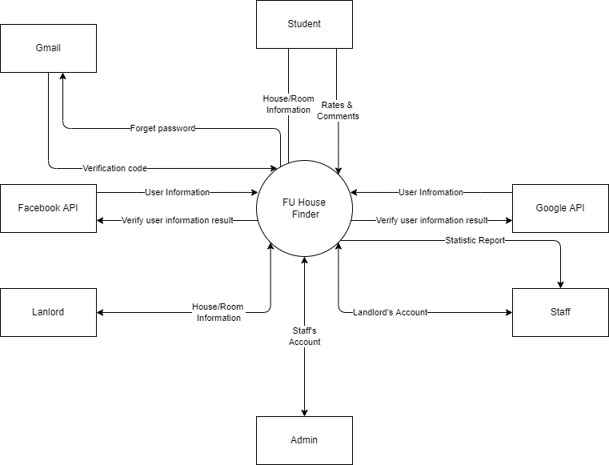

## 2. User Requirements

### 2.1 Actors

|  |  |  |
| --- | --- | --- |
| **#** | **Actor** | **Description** |
| 1 | Administrator | Administrator of the system; Manage accounts of Staffs |
| 2 | Staff | Staffs of the offices of the University; Manage accounts of Landlords and view statistics reports |
| 3 | Landlord | People having houses for rent; Manage their houses and rooms and their information |
| 4 | Student | People finding for houses to rent; Can search for available houses in the system |

### 2.2 Use Cases

#### 2.2.1 Diagram(s)

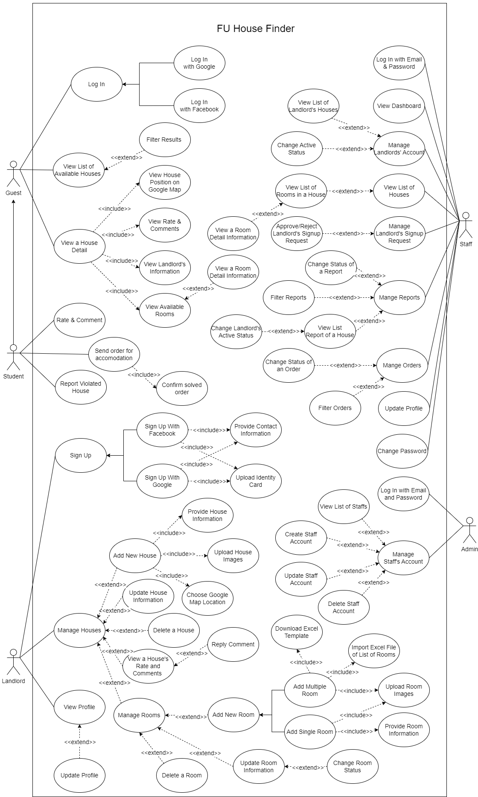

#### 2.2.2 Descriptions

|  |  |  |  |
| --- | --- | --- | --- |
| **ID** | **Use Case** | **Actors** | **Use Case Description** |
| 01 | Log In | Guest | Guest logs into the system |
| 02 | View List Of Available Houses | Guest | Guest views list of houses |
| 03 | Filter Available Houses | Guest | Guest searches for houses by name or filters it by category or by map |
| 04 | View a House Detail | Guest | Guest views the detail information of house |
| 05 | View House Position on Google Map | Guest | Guest views specific location of a house on Google Map |
| 06 | View Rate and Comments | Guest | Guest views other user rate and reviews of a house |
| 07 | View Landlord’s Information | Guest | Guest views landlord’s information of a house |
| 08 | View Avialable Rooms | Guest | Guest views list of available rooms in a house |
| 09 | View a Room Detail Information | Guest | Guest views a room’s detail information |
| 10 | Rate and Comment | Student | Student rates and comments the house |
| 11 | Send Order for Accommodation | Student | Student fills out his contact information and desired demand to Staff |
| 12 | Report Violated House | Student | Student reports the violated house |
| 13 | Log In with Email and Password | Admin | Admin logs into the system |
| 14 | Manage Staff’s Account | Admin | Admin views the list of all staff accounts and can be change active status of the staff |
| 15 | Change Password | Admin | Admin changes login password |
| 16 | Log In with Email and Password | Staff | Staff logs into the system |
| 17 | View Dashboard | Staff | Staff views list of available houses and list of landlord’s request. Staff can be search for houses & statistics by name or filter it by category at the same time can also accept or decline landlord’s request |
| 18 | Manage Landlords’ Account | Staff | Staff views list of landlords’ accounts |
| 19 | View List of Landlord’s Houses |  | Staff views list of all houses of a landlord |
| 20 | Change Active Status | Staff | Staff changes active status of a landlord then houses of this landlord does not appear for students |
| 21 | View List of Houses | Staff | Staff views list of all houses in the system |
| 22 | View List Rooms of a House | Staff | Staff views list of all rooms of a house |
| 23 | View a Room Detail Information | Staff | Staff views detail information of a room |
| 24 | Manage Landlords’ Signup Request | Staff | Staff views a list of all landlords’ signup requests |
| 25 | Approve/Reject Landlord’s Signup Request | Staff | Staff approves or rejects a landlord’s signup request |
| 26 | Manage Reports | Staff | Staff views a list of reports send by students |
| 27 | Change Status of a Report | Staff | Staff changes resolution status of a report |
| 28 | Filter Reports | Staff | Staff filters reports by reported date, resolution status |
| 29 | View List of Reported House | Staff | Staff views a list of reported houses |
| 30 | View List Report of a House | Staff | Staff views a list of reports send by students of a house |
| 31 | Manage Orders | Staff | Staff views list of students’ accommodation orders |
| 32 | Change Status of an Order |  | Staff changes the resolution status of an order |
| 33 | Filter Orders | Staff | Staff filters orders by ordered date, resolution status, etc |
| 34 | Update Profile | Staff | Staff views and updates the profile |
| 35 | Change Password | Staff | Staff changes password to log in the system |
| 36 | Sign Up | Landlord | Landlord registers for an account |
| 37 | Provide Contact Information | Landlord | Landlord provides his contact information for register account |
| 38 | Upload Identity Card | Landlord | Landlord uploads his identity card imgae for register account |
| 39 | Log In | Landlord | Landlord logs into the system |
| 40 | Manage Houses | Landlord | Landlord views list of rooms, detail information of room at the same time can also add new, update, delete, change status the room |
| 41 | Add New House | Landlord | Landlord provides information of a new house to add it to the system |
| 42 | Provide House Information | Landlord | Landlord imports information of the house by excel file |
| 43 | Upload House Images | Landlord | Landlord uploads images of a house |
| 44 | Choose Google Map Location | Landlord | Landlord chooses a location on Google Map for a house |
| 45 | Update House Information | Landlord | Landlord updates detail information of a house |
| 46 | Delete a House | Landlord | Landlord deletes a house |
| 47 | View House’s Rate and Comments | Landlord | Landlord views students’ rate and comments on one of their house |
| 48 | Reply Comment | Landlord | Landlord replies students’ comments |
| 49 | Add New Room | Landlord | Landlord adds new room to a house |
| 50 | Add Single Room | Landlord | Landlord fills out information in a form to add a new room to a house |
| 51 | Add Multiple Room | Landlord | Landlord uploads templated excel file to upload a list of rooms to a house |
| 52 | Download Excel Template | Landlord | Landlord downloads an excel template to fill out information of rooms |
| 53 | Import Excel File of List Rooms | Landlord | Landlord imports an excel file to add a list of rooms to a house |
| 54 | Upload Room Images | Landlord | Landlord uploads a folder of images of rooms named as convention |
| 55 | Provide Room Information | Landlord | Landlord provides detail information of a room |
| 56 | Update Room Information | Landlord | Landlord updates detail information of a room |
| 57 | Change Room Status | Landlord | Landlord changes the availability status of a room |
| 58 | Delete a Room | Landlord | Landlord deletes a room |
| 59 | View Profile | Landlord | Landlord views the profile |
| 60 | Update Profile | Landlord | Landlord updates the profile |

## 3. Functional Requirements

### 3.1 System Functional Overview

#### 3.1.1 Screens Flow

Student

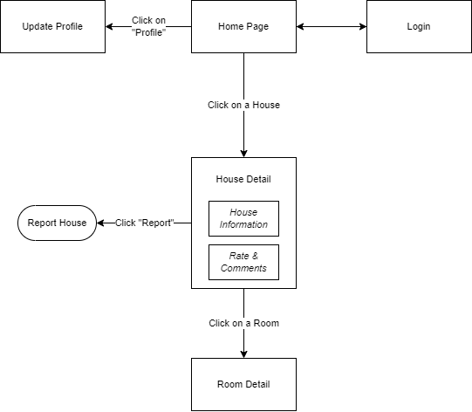

Figure 1-1: Screen Flow for Student

Landlord

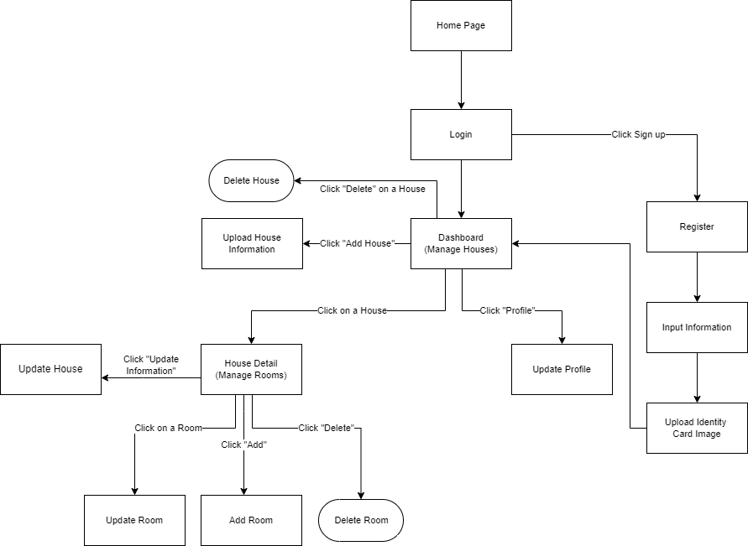

Figure 1-2: Screen Flow for Landlord

Staff

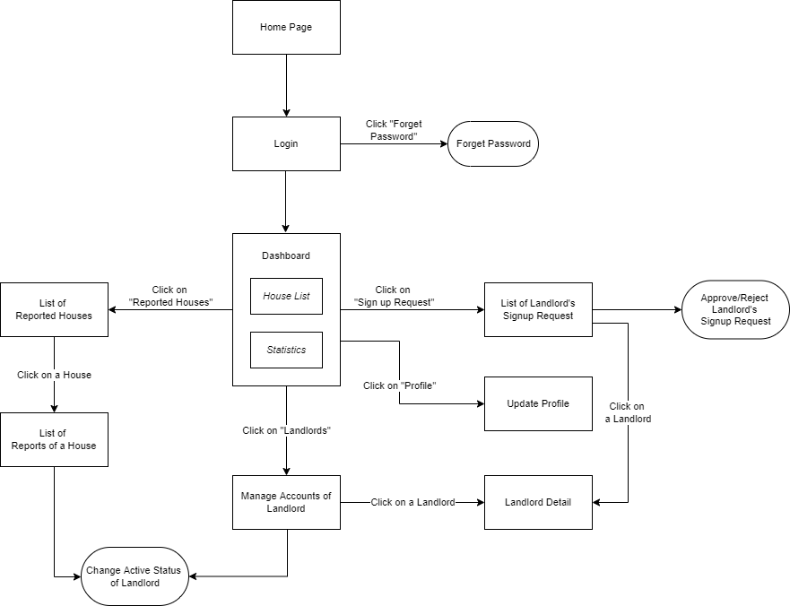

Figure 1-3: Screen Flow for Staff

Admin

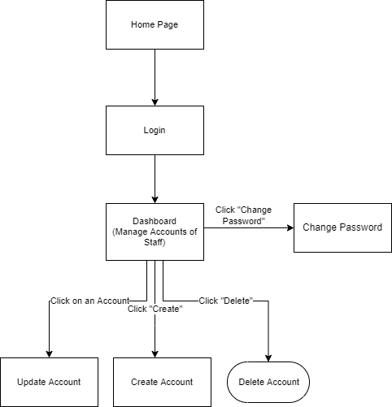

Figure 1-3: Screen Flow for Admin

#### 3.1.2 Screen Descriptions

|  |  |  |  |
| --- | --- | --- | --- |
| **#** | **Feature** | **Screen** | **Description** |
|  | View List Houses | Home Page | View list of houses |
|  | Search & Filter House | Home Page | Search for houses by name or filter it by category |
|  | Interact with map | Home Page | Use the map to find the location of the house |
|  | View House Detail | House Details | Display detail information of house |
|  | View Room Detail | Room Details | Display detail information of room |
|  | Report House | Report House | User reports the house |
|  | Login | User Login | User logs into the system |
|  | Register | User Register | User registers for an account |
|  | Register | Register [Landlord] | Landlord registers for an account |
|  | Verify Information Of Landlord | Input Information [Landlord] | Get information of landlord |
|  | Verify Identity Card Of Landlord | Upload Identity Card Image [Landlord] | Get identity card of landlord |
|  | View List Houses | Dashboard [Landlord] | Landlord views list of houses |
|  | Search & Filter House | Dashboard [Landlord] | Landlord searché for houses by name or filters it by category |
|  | Upload House Information | Upload House Information [Landlord] | Landlord imports information of the house |
|  | Manage Rooms | House Detail [Landlord] | Display detail information of house |
|  | Search & Filter Room | House Detail [Landlord] | Landlord searché for rooms by name or filters it by category |
|  | Update House | Update House [Landlord] | Landlord updates the house |
|  | Delete House | Delete House [Landlord] | Landlord deletes the house |
|  | Update Room | Update Room [Landlord] | Landlord updates the room |
|  | Add Room | Add Room [Landlord] | Landlord adds new the room |
|  | Delete Room | Delete Room [Landlord] | Landlord deletes the room |
|  | Update Proflie | Update Proflie [Landlord] | Landlord updates the proflie |
|  | View List Houses & Statistics | Dashboard [Staff] | Staff view list of available houses |
|  | Search & Filter House & Statistic | Dashboard [Staff] | Staff searches for houses & statistics by name or filter it by category |
|  | Accept Or Decline Landlord’s Signup Request | List Of Landlord’s Signup Request [Staff] | Staff views list of landlord’s request and accepts or decline |
|  | Update Proflie | Update Proflie [Staff] | Staff updates the proflie |
|  | View List Accounts Of Landlords | Landlords List [Staff] | Staff views list of landlords |
|  | View Landlord Detail | Landlord Detail [Staff] | Staff views detail information of landlord |
|  | View List Of Reported Houses | List Of Reported Houses [Staff] | Staff views list of reported houses |
|  | View List Accounts Of Staffs | Dashboard [Admin] | Admin views the list of all staff accounts |
|  | Search & Filter Staff | Dashboard [Admin] | Admin searches for staffs by name or filter it by category |
|  | Change Password | Change Password [Admin] | Admin changes login password |
|  | Create Staff Account | Create Account [Admin] | Admin creates account for staff |
|  | Update Staff Account | Update Account [Admin] | Admin updates account of staff |
|  | Detele Staff Account | Detele Account [Admin] | Admin deletes account of staff |

#### 3.1.3 Screen Authorization

|  |  |  |  |  |  |
| --- | --- | --- | --- | --- | --- |
| **Screen** | **Guest** | **Student** | **Landlord** | **Staff** | **Admin** |
| Home Page | X | X | X | X | X |
| House Details | X | X | X | X | X |
| Room Details | X | X | X | X | X |
| Report House |  | X |  |  |  |
| User Login |  | X | X | X | X |
| User Register | X |  |  |  |  |
| Register [Landlord] |  |  | X |  |  |
| Input Information [Landlord] |  |  | X |  |  |
| Upload Identity Card Image [Landlord] |  |  | X |  |  |
| Dashboard [Landlord] |  |  | X |  |  |
| Upload House Information [Landlord] |  |  | X |  |  |
| House Detail [Landlord] |  |  | X |  |  |
| Update House [Landlord] |  |  | X |  |  |
| Delete House [Landlord] |  |  | X |  |  |
| Update Room [Landlord] |  |  | X |  |  |
| Add Room [Landlord] |  |  | X |  |  |
| Delete Room [Landlord] |  |  | X |  |  |
| Update Proflie [Landlord] |  |  | X |  |  |
| Dashboard [Staff] |  |  |  | X |  |
| List Of Landlord’s Signup Request [Staff] |  |  |  | X |  |
| Update Proflie [Staff] |  |  |  | X |  |
| Landlords List [Staff] |  |  |  | X |  |
| Landlord Detail [Staff] |  |  |  | X |  |
| List Of Reported Houses [Staff] |  |  |  | X |  |
| Dashboard [Admin] |  |  |  |  | X |
| Change Password [Admin] |  |  |  |  | X |
| Create Account [Admin] |  |  |  |  | X |
| Update Account [Admin] |  |  |  |  | X |
| Detele Account [Admin] |  |  |  |  | X |

#### 3.1.4 Non-Screen Functions

|  |  |  |  |
| --- | --- | --- | --- |
| **#** | **Feature** | **System Function** | **Description** |
| 1 | Login with Facebook | Login | User logs in the system with his Facebook account |
| 2 | Login with Google | Login | User logs in the system with his Google account |
| 3 | Import File Excel | Sign up & Manage Houses | Convert data from Excel file into house & room information |
| 4 | Forget Password | Login | System send verification code to user Email to reset password |

#### 3.1.5 Entity Relationship Diagram

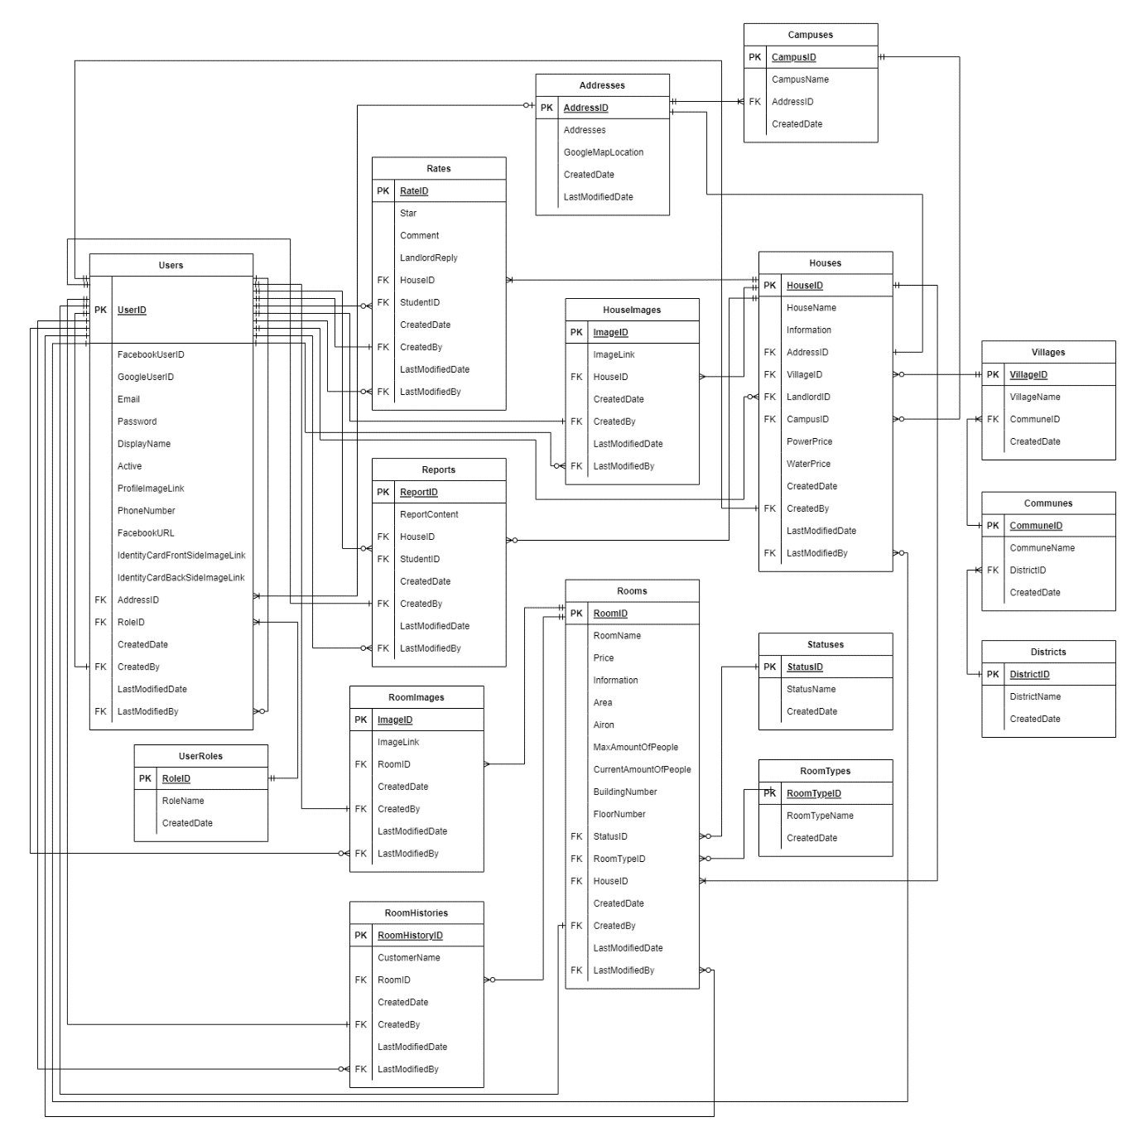

**Entities Description**

|  |  |  |
| --- | --- | --- |
| **#** | **Entity** | **Description** |
| 1 | Addresses | Used to store the address of User, House & Campus |
| 2 | Campuses | Used to store Campuses of FPT university |
| 3 | UserRoles | Used to store the role of each User |
| 4 | Users | Used to store Users in the system |
| 5 | Districts | Used to store Districts around the school |
| 6 | Communes | Used to store Communes around the school |
| 7 | Villages | Used to store Villages around the school |
| 8 | Houses | Used to store Houses |
| 9 | Statuses | Used to store Statuses of Room |
| 10 | RoomTypes | Used to store Types of Room |
| 11 | Rooms | Used to store Rooms |
| 12 | Rates | Used to store Rating & Comments of User |
| 13 | ImagesOfHouse | Used to store Images of House |
| 14 | ImagesOfRoom | Used to store Images of Room |
| 15 | Reports | Used to store student's Reports for House |
| 16 | RoomHistories | Used to store Histories of people staying in the House, for the landlord to voluntarily add if there is a need to manage & monitor |

### 3.2 Home page

* Function trigger: User accesses the website
* Function description:
  + Role: Guest, Student
  + Purpose: User could view list of available houses and filter the results
* Screen layout:

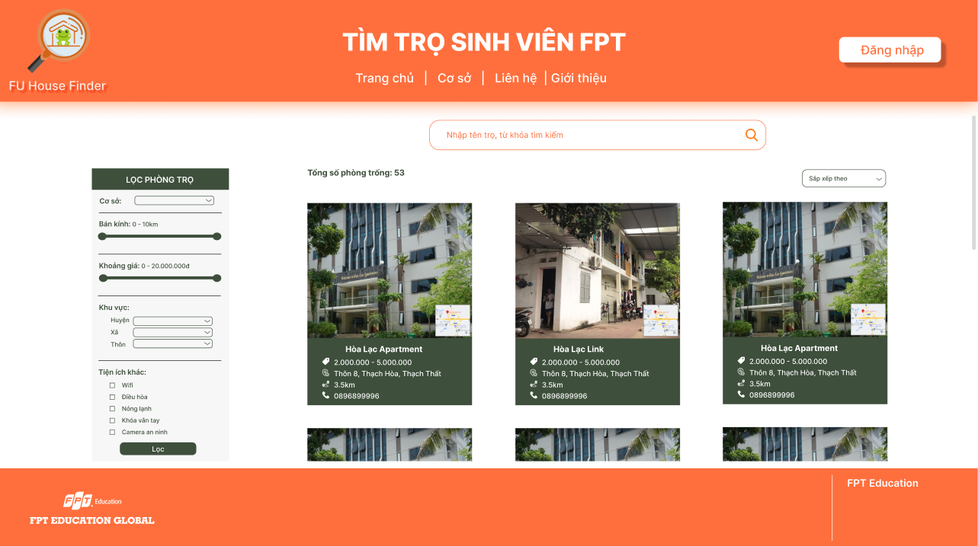

### 3.3 Login/Signup

* Function trigger: User clicks “Đăng nhập” from Home Page
* Function description:
  + Role: Guest
  + Purpose: Guest could sign up for an account or log in to access more functions
* Screen layout: 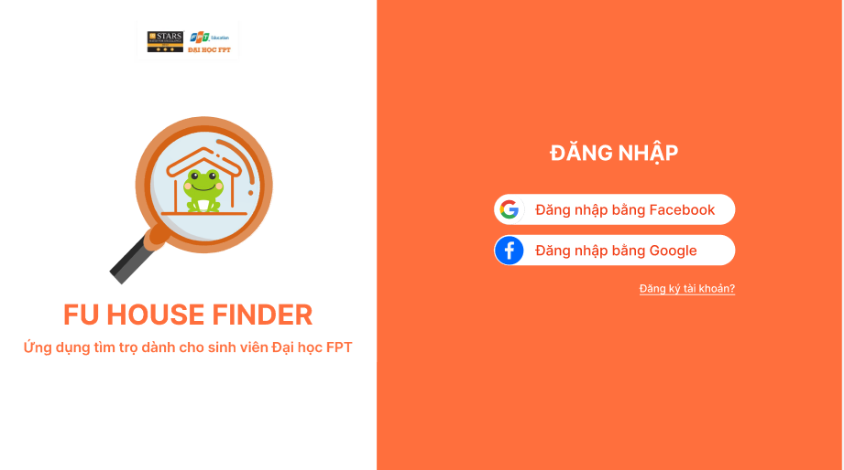

### 3.4 House Detail

* Function trigger: User clicks on one house from Home page
* Function description:
  + Role: Guest, student
  + Purpose: View a house detail information (landlord’s information, available rooms, etc.)
* Screen layout: 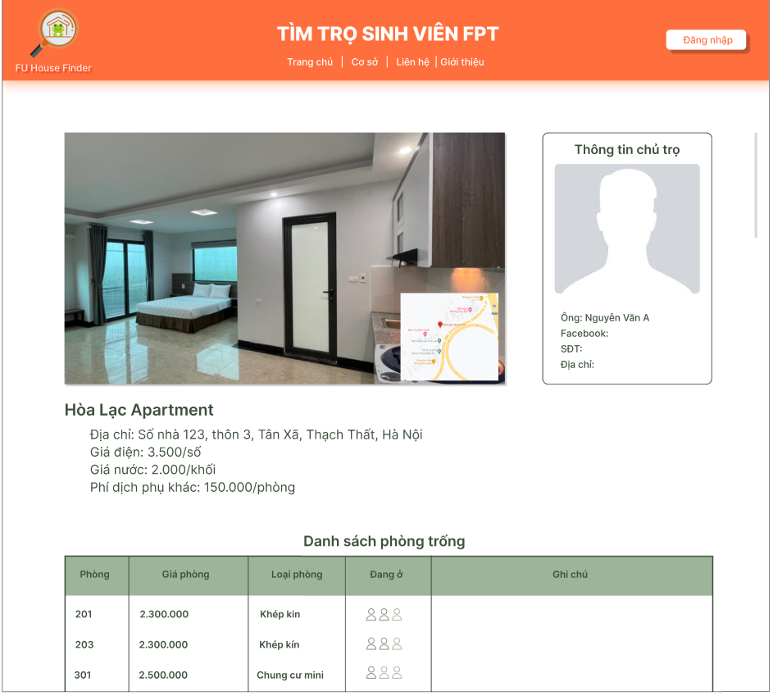

### 3.5 Room Detail

* Function trigger: User clicks on one Room from a House Detail
* Function description:
  + Role: Guest, student
  + Purpose: View a room detail information (images, price, etc.)
* Screen layout: 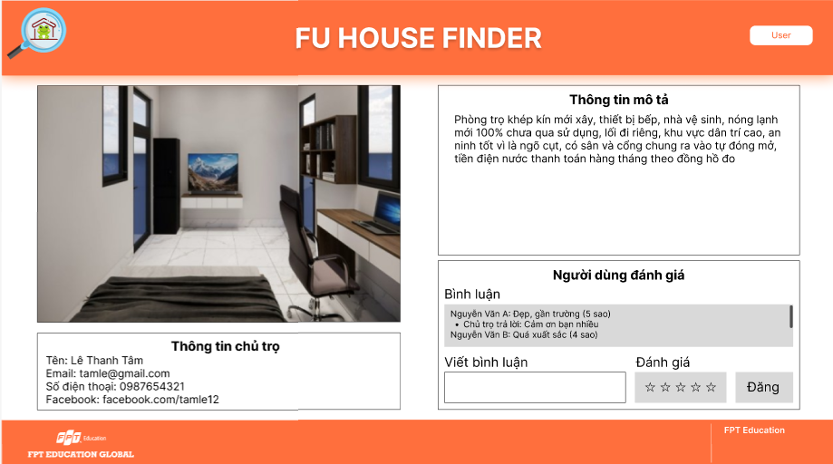

### 3.6 Report House

* Function trigger: Student clicks “Báo cáo” in one House Detail
* Function description:
  + Role: Student
  + Purpose: Student uses to report an unusual house
* Screen layout:

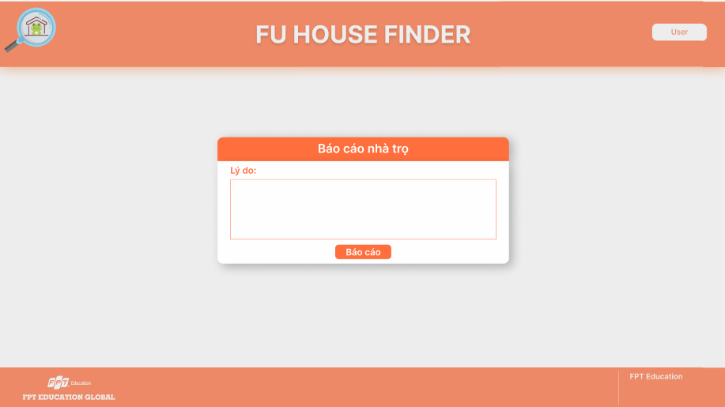

### 3.7 Register [Landlord]

* Function trigger: User click the landlord’s register button
* Function description:
  + Role: Guest
  + Purpose: Landlord register for an account
* Screen layout:

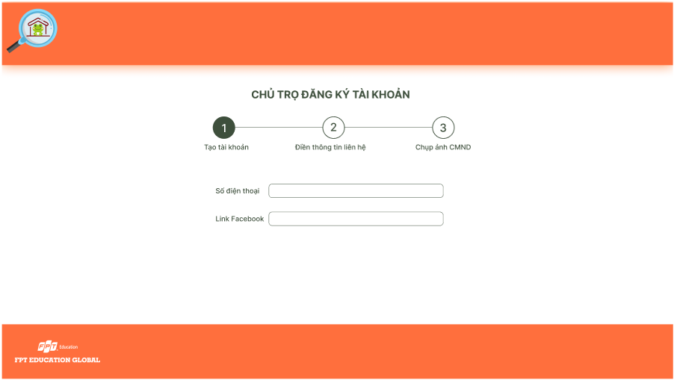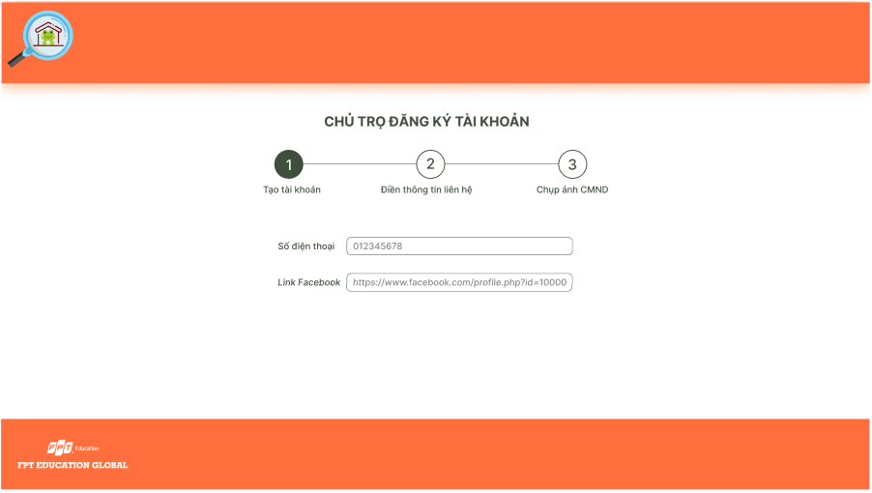 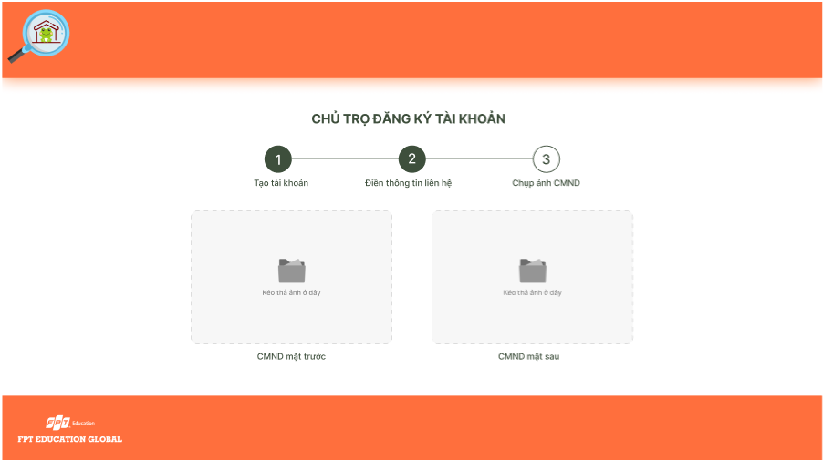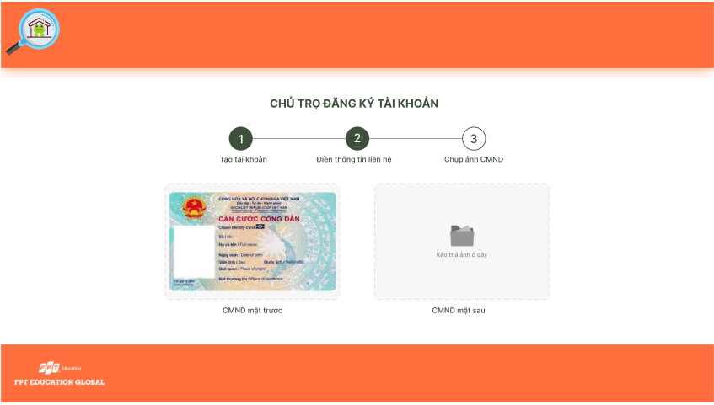 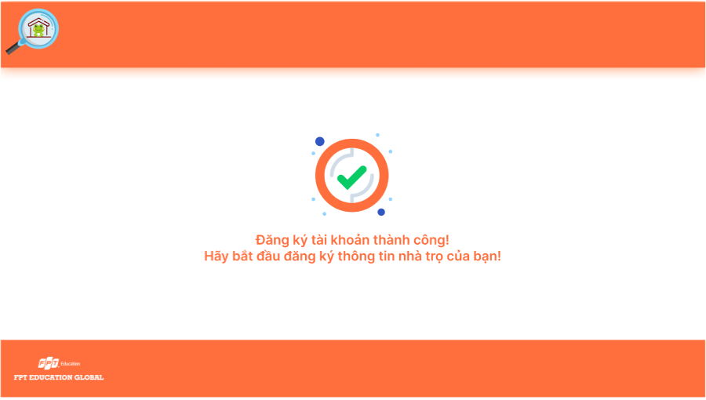

### 3.8 Dashboard [Landlord]

* Function trigger: Landlord accesses the website
* Function description:
  + Role: Landlord
  + Purpose: Landlord view list of houses and search for houses by name or filter it by category
* Screen layout:

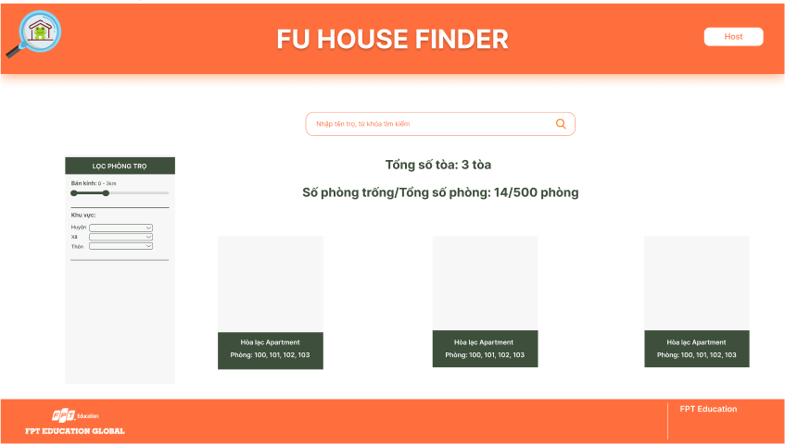

### 3.9 Upload House Information [Landlord]

* Function trigger: Landlord clicks the import button
* Function description:
  + Role: Landlord
  + Purpose: Landlord import information of the house
* Screen layout:

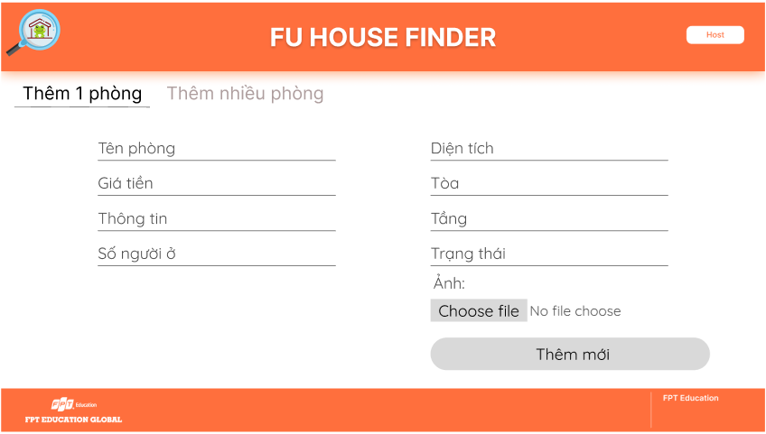 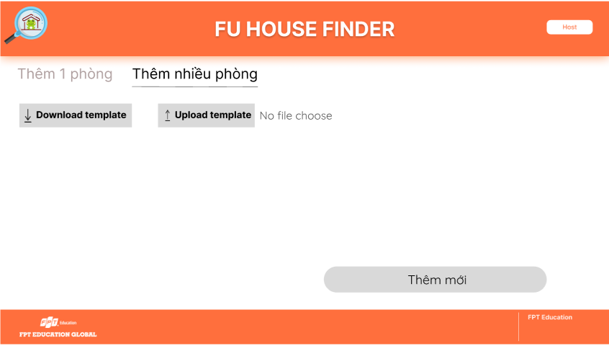

### 3.10 House Detail [Landlord]

* Function trigger: Landlord clicks each item of list houses
* Function description:
  + Role: Landlord
  + Purpose: Display detail information of house and search for rooms by name or filter it by category
* Screen layout:

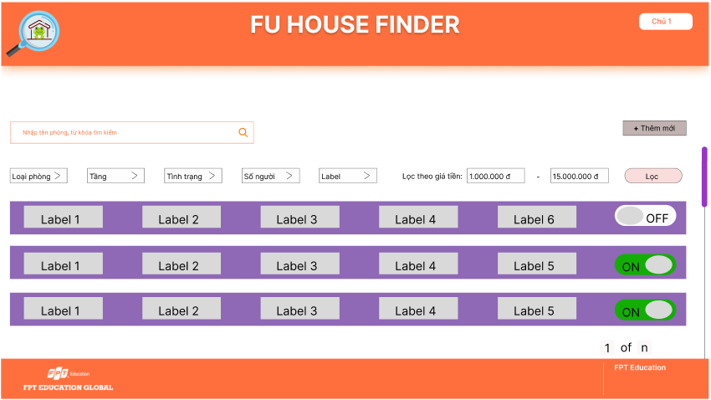

### 3.11 Update House [Landlord]

* Function trigger: Landlord clicks the update button
* Function description:
  + Role: Landlord
  + Purpose: Landlord update the house
* Screen layout:

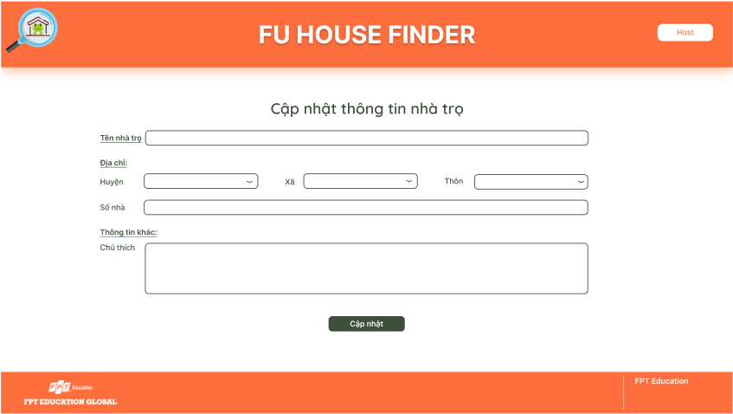

### 3.12 Delete House [Landlord]

* Function trigger: Landlord clicks the delete button
* Function description:
  + Role: Landlord
  + Purpose: Landlord delete the house
* Screen layout:

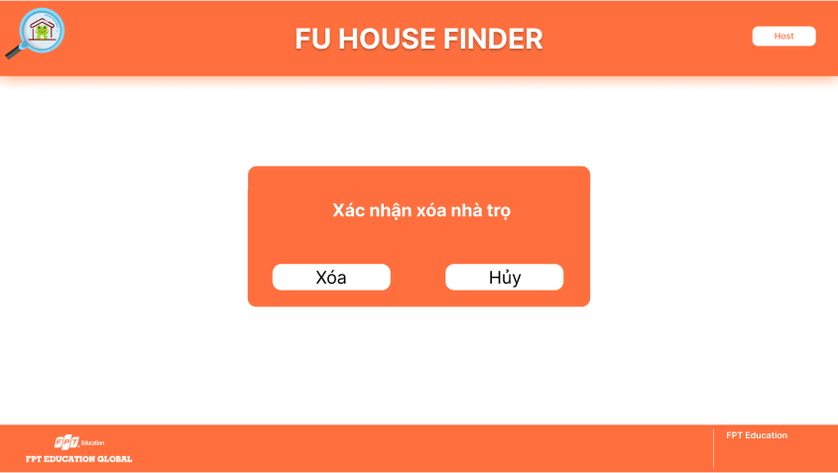

### 3.13 Update Room [Landlord]

* Function trigger: Landlord clicks the update button of each room in the list
* Function description:
  + Role: Landlord
  + Purpose: Landlord update the room
* Screen layout:

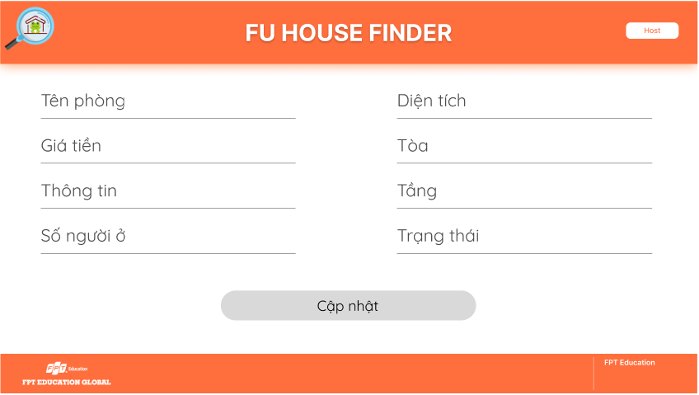

### 3.14 Add Room [Landlord]

* Function trigger: Landlord clicks the add button
  + Function description:
  + Role: Landlord
* Purpose: Landlord add the new room
* Screen layout:

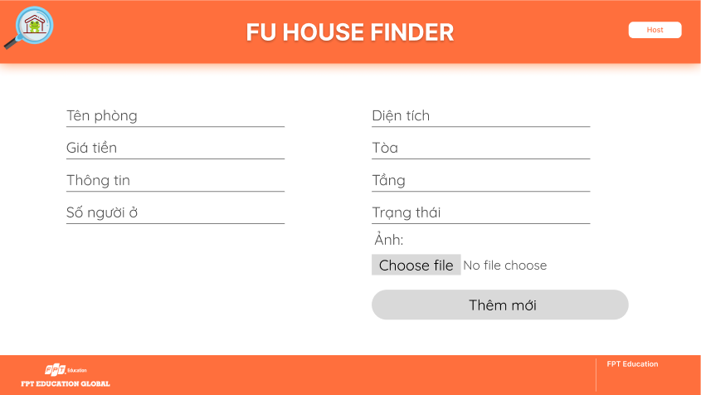

### 3.15 Delete Room [Landlord]

* Function trigger: Landlord clicks the delete button of each room in the list
* Function description:
  + Role: Landlord
  + Purpose: Landlord delete the room
* Screen layout:

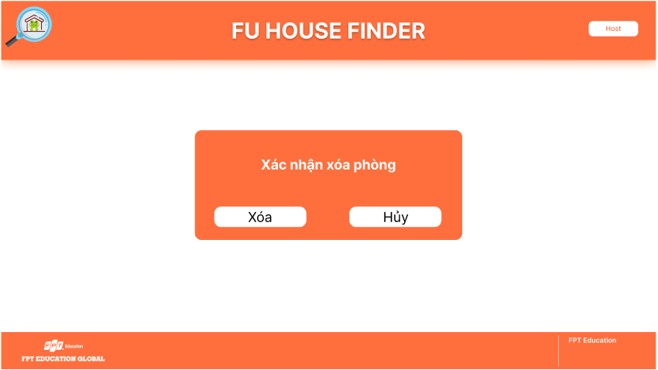

### 3.16 Dashboard [Staff]

* Function trigger: Staff accesses the website
* Function description:
  + Role: Staff
  + Purpose: Staff view houses and rooms statistics
* Screen layout:

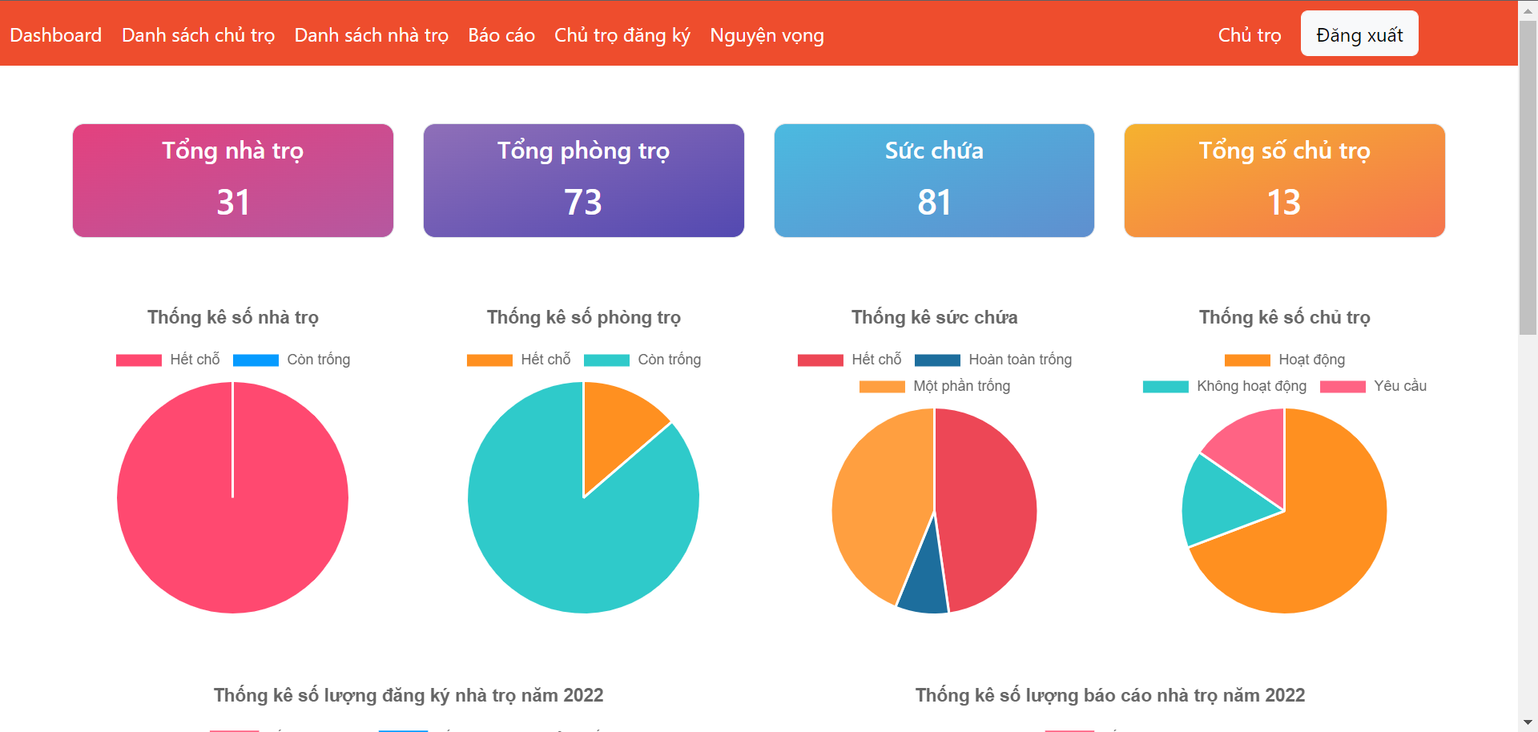

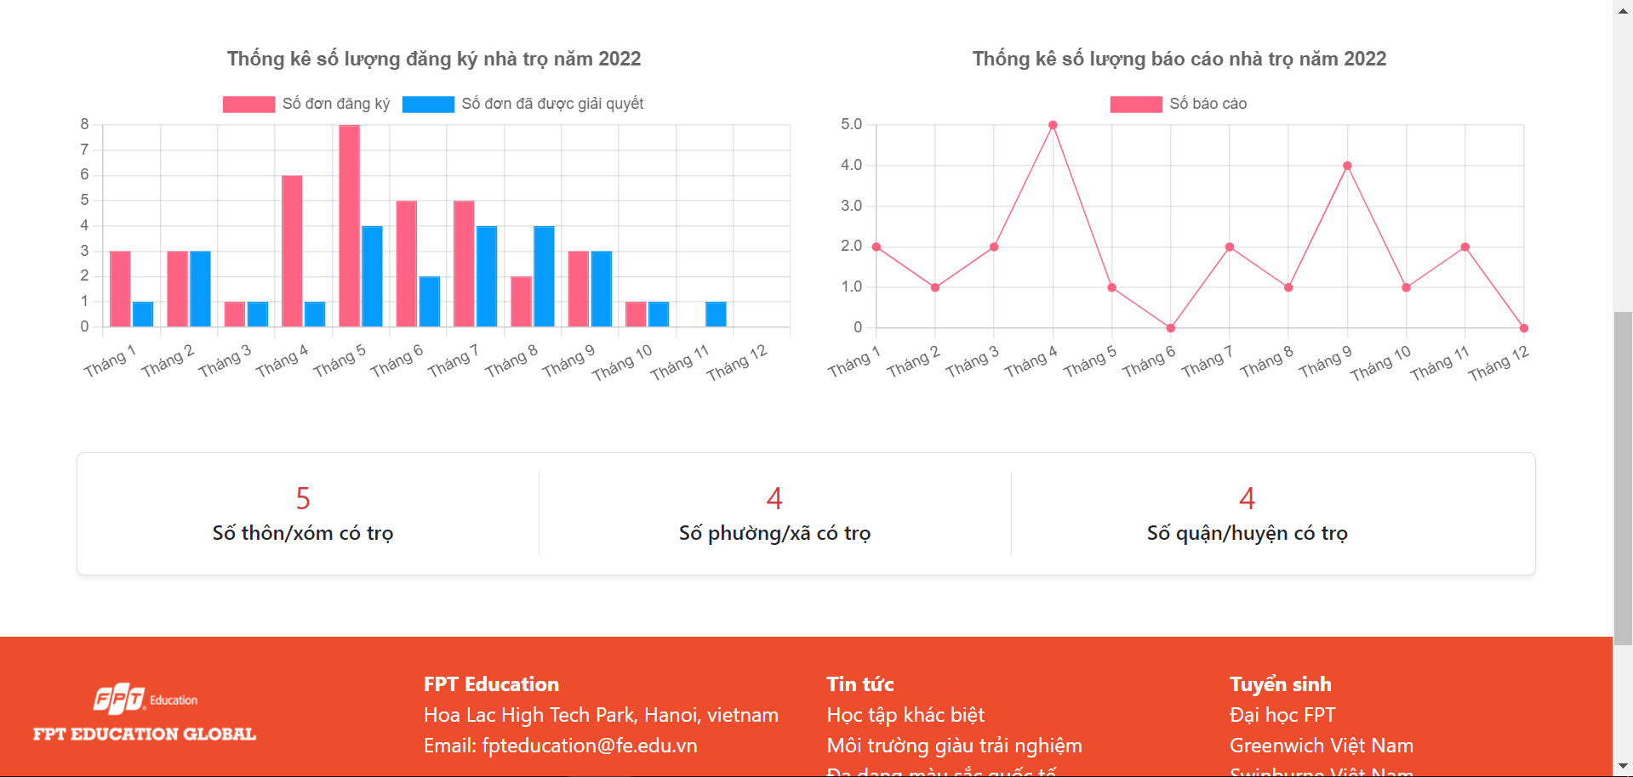

### 3.17 List Of Landlords [Staff]

* Function trigger: Staff clicks the list landlords button in the navbar
* Function description:
  + Role: Staff
  + Purpose: Staff view houses statistics, list of landlords and filter the results
* Screen layout:

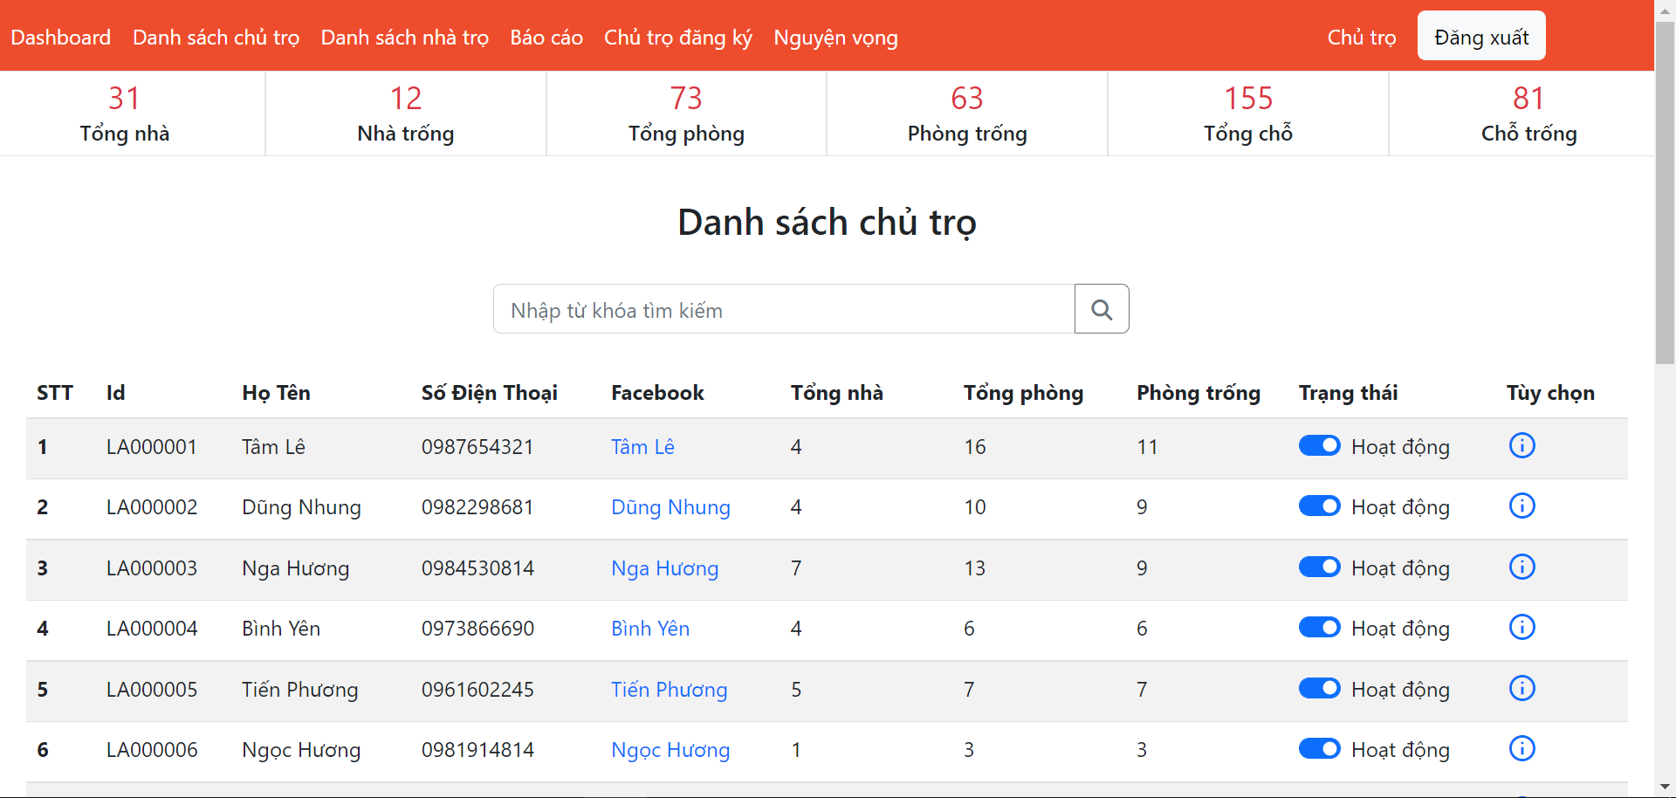

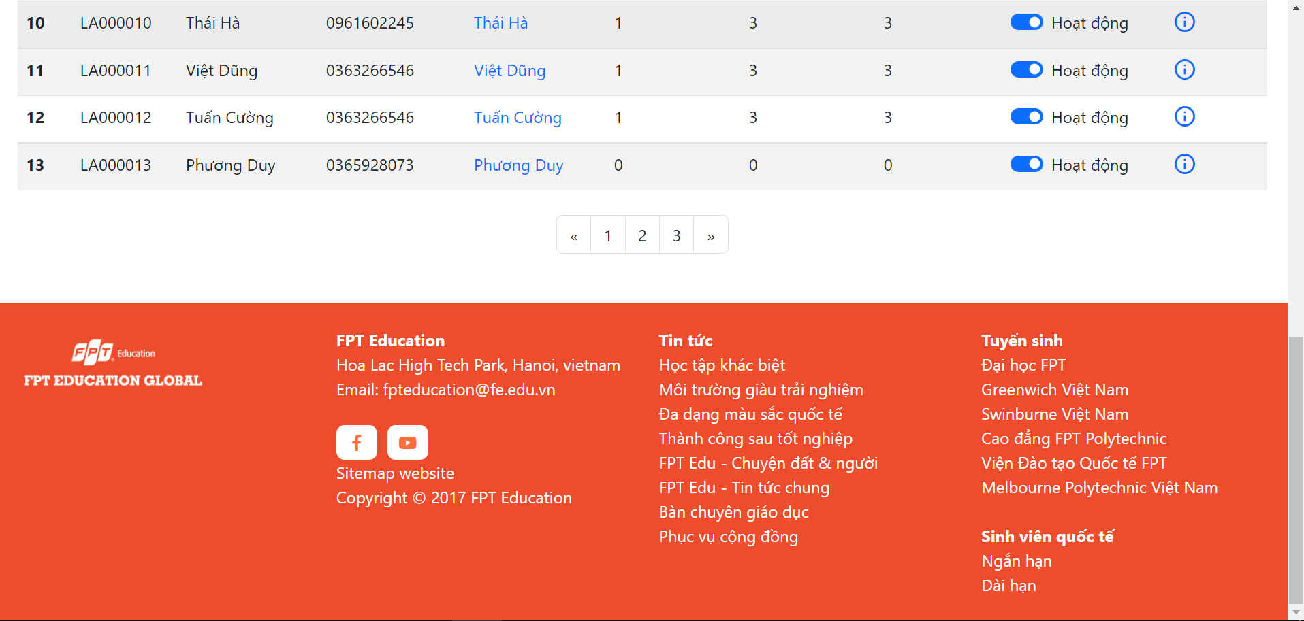

### 3.18 Landlord Detail [Staff]

* Function trigger: Staff clicks the detail button of each landlord in the list
* Function description:
  + Role: Staff
  + Purpose: Staff view houses statistics, detail information of landlord, list houses of this landlord and filter the results
* Screen layout:

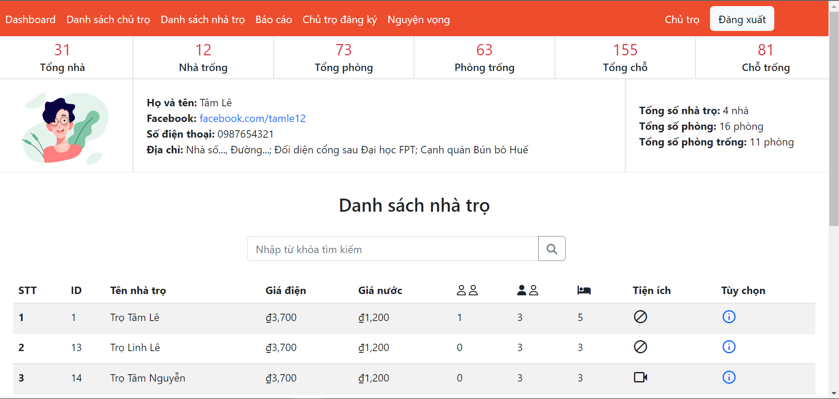

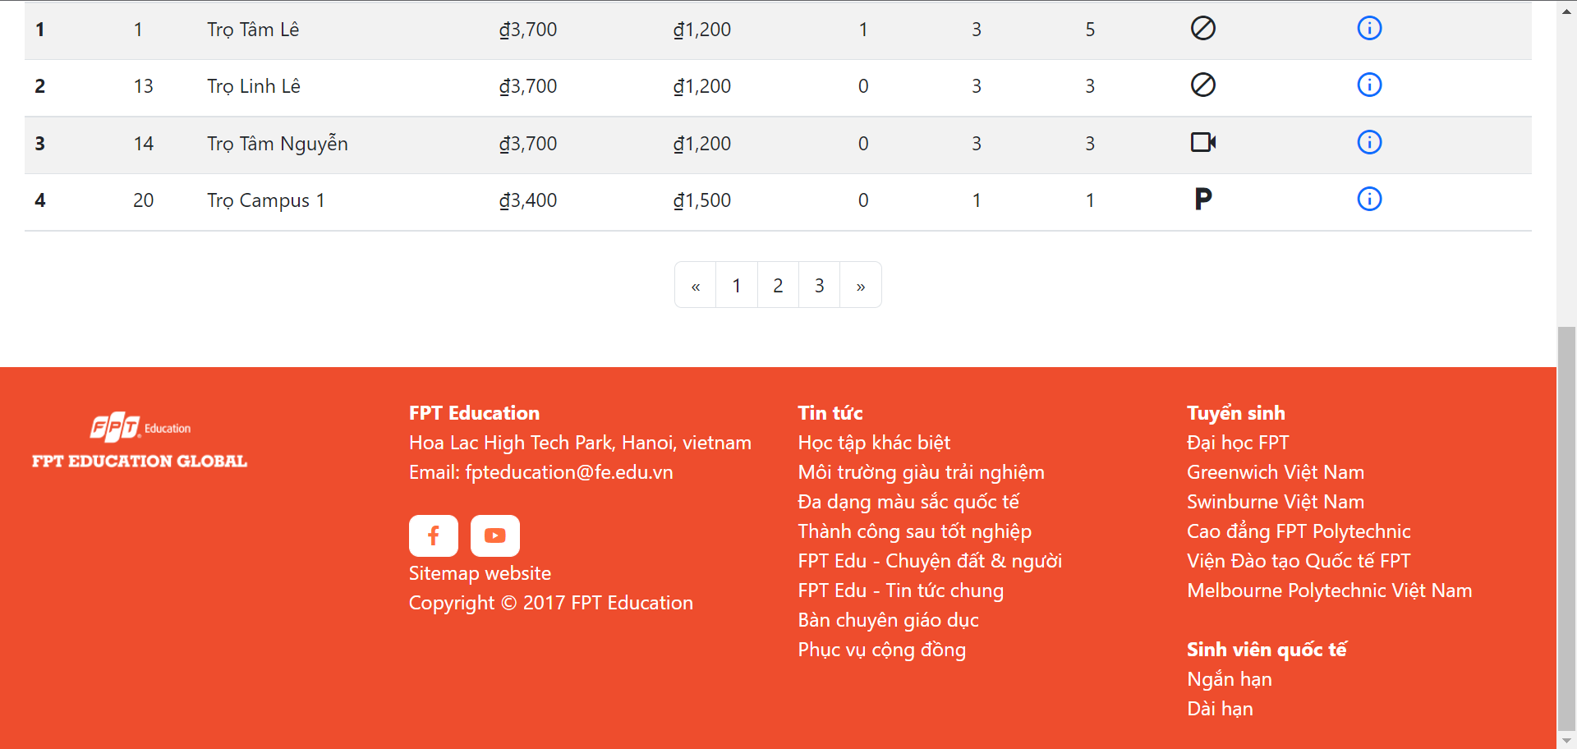

### 3.19 House Detail [Staff]

* Function trigger: Staff clicks the detail button of each house in the list
* Function description:
  + Role: Staff
  + Purpose: Staff view houses statistics, detail information of house, list rooms of this house and filter the results
* Screen layout:

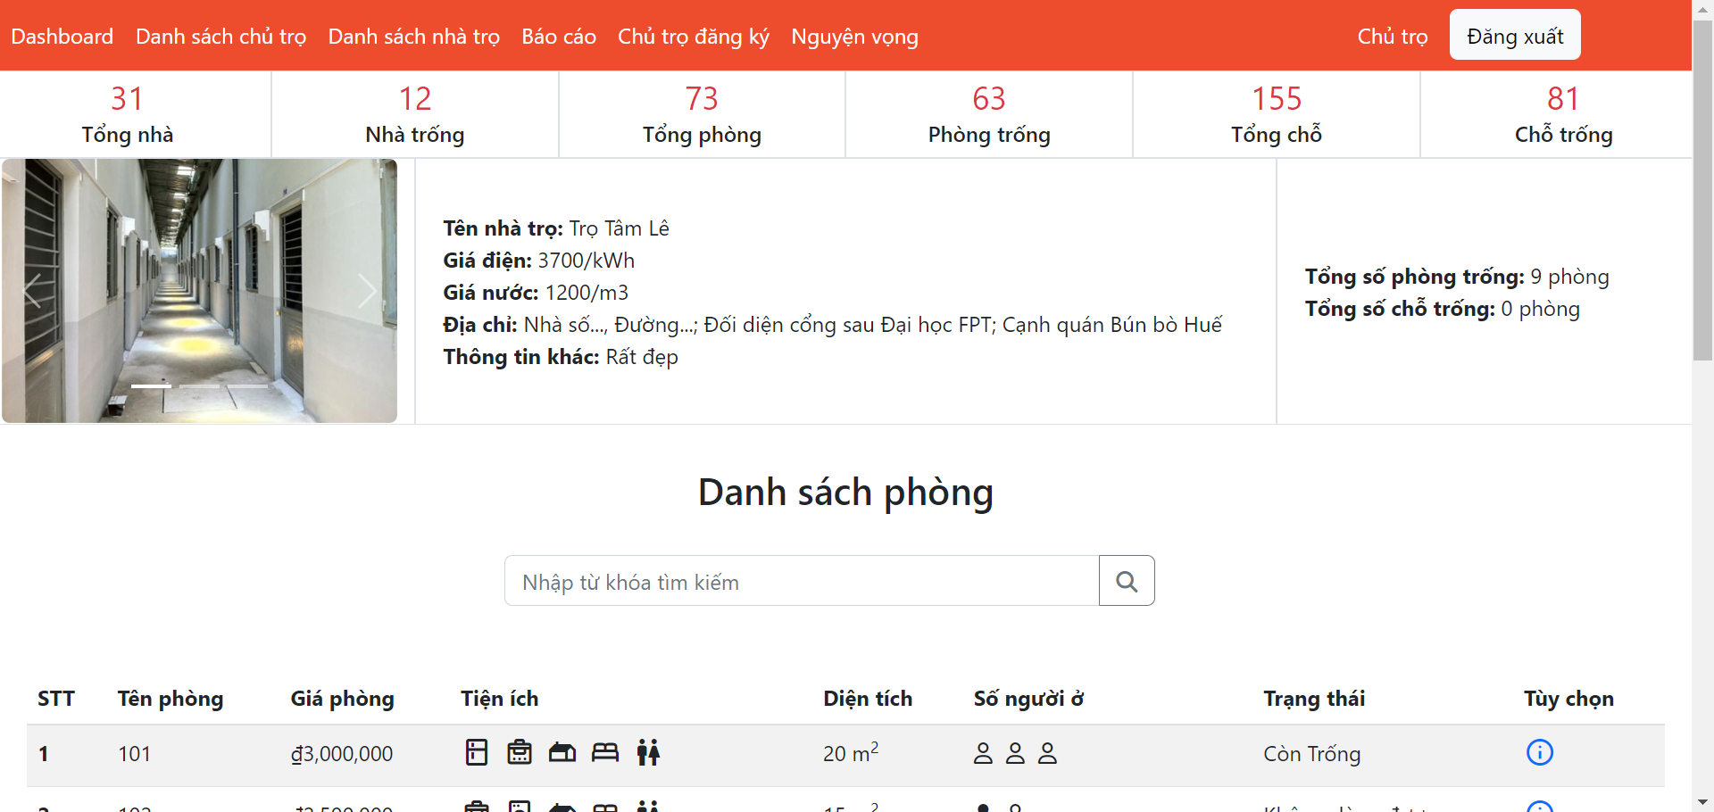

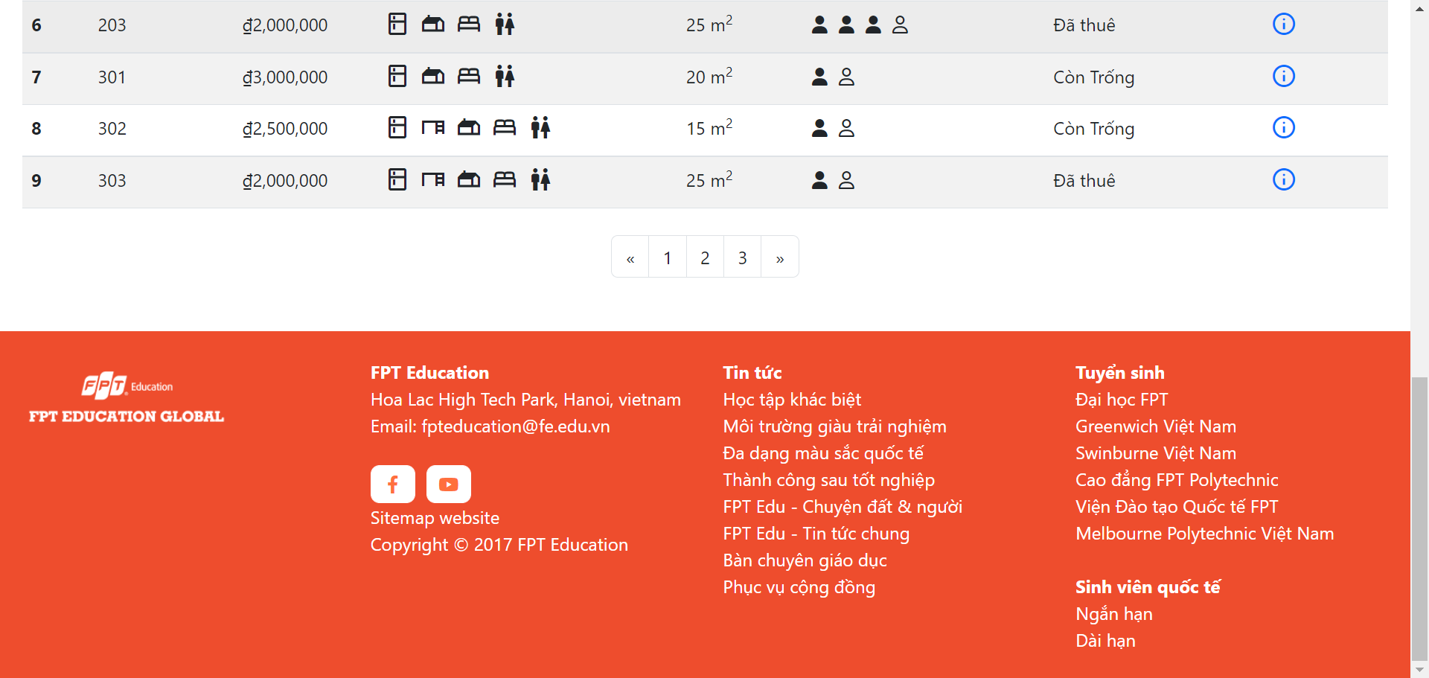

### 3.20 Room Detail [Staff]

* Function trigger: Staff clicks the detail button of each room in the list
* Function description:
  + Role: Staff
  + Purpose: Staff view detail information of this room
* Screen layout:

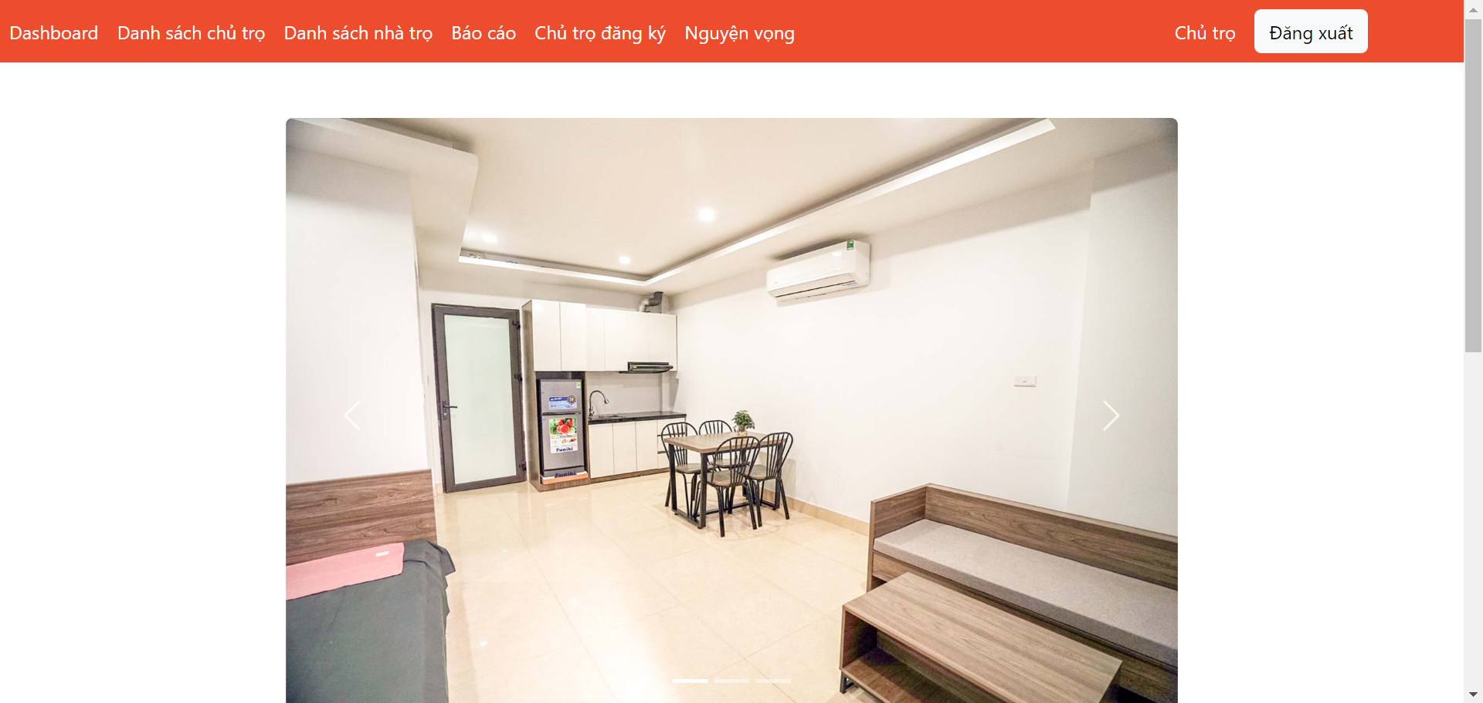

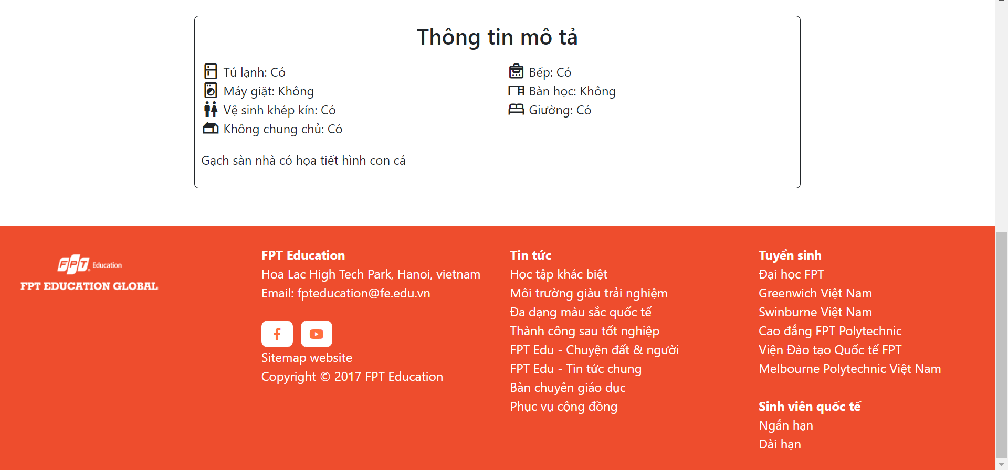

### 3.21 List Of Houses [Staff]

* Function trigger: Staff clicks the list houses button in the navbar
* Function description:
  + Role: Staff
  + Purpose: Staff view houses statistics, list of houses and filter the results
* Screen layout:

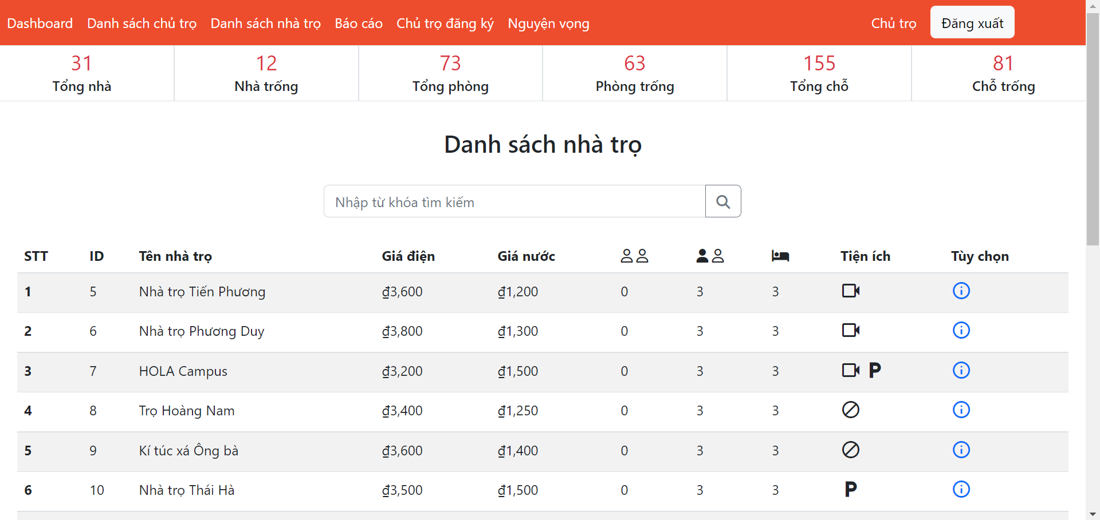

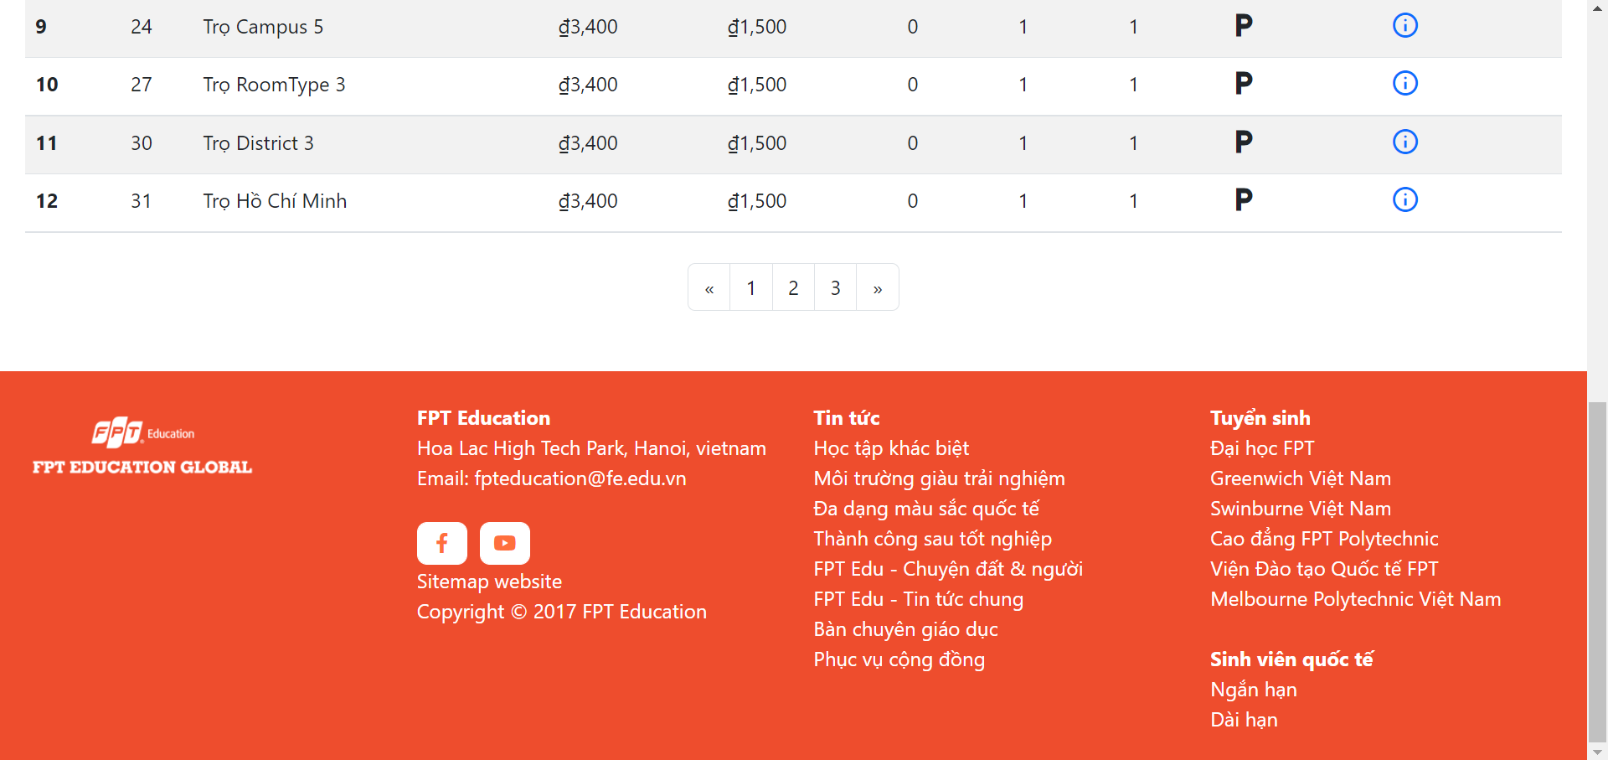

### 3.22 List Of Reports [Staff]

* Function trigger: Staff clicks the list reports button in the navbar
* Function description:
  + Role: Staff
  + Purpose: Staff view list of reports, report of each house and filter the results
* Screen layout:

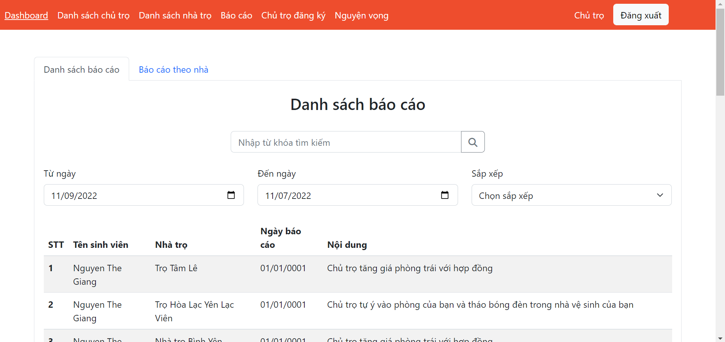

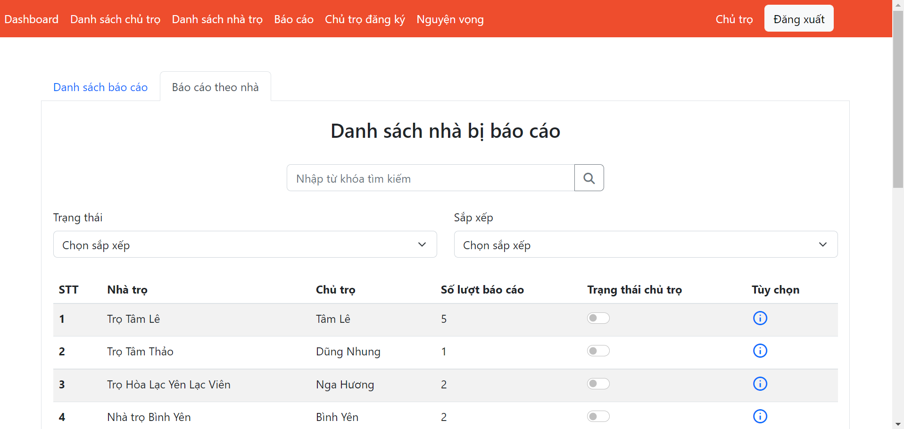

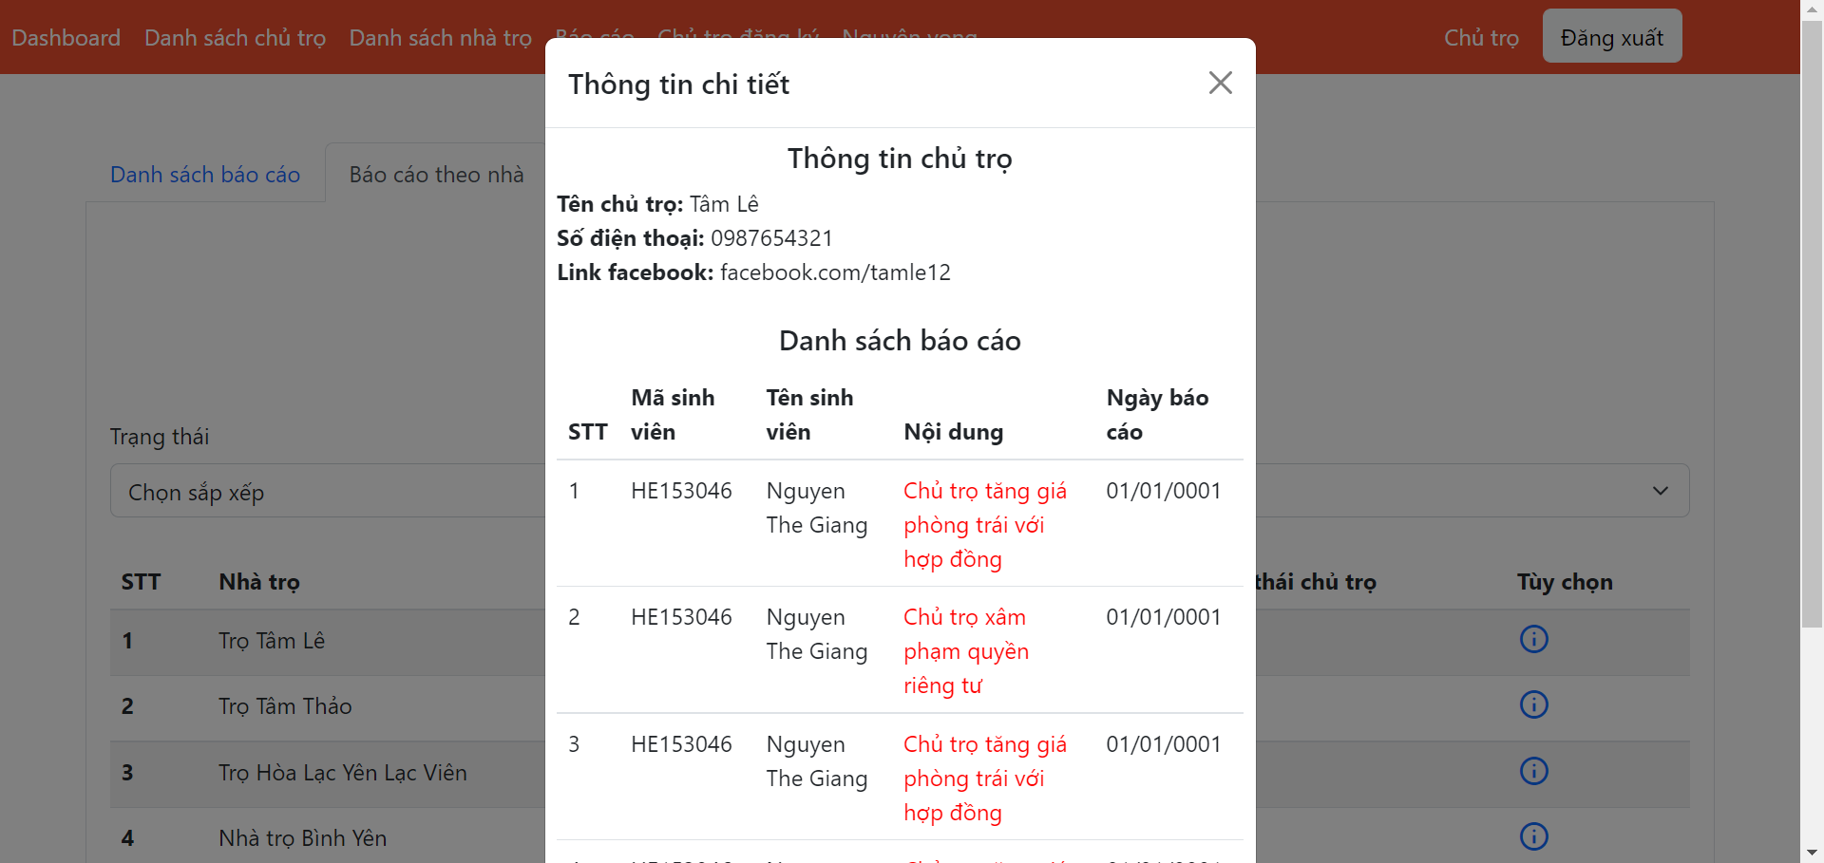

### 3.21 List Of Landlords Signup Request [Staff]

* Function trigger: Staff clicks the list requests button in the navbar
* Function description:
  + Role: Staff
  + Purpose: Staff view list of request and filter the results
* Screen layout:

### 3.22 List Of Orders [Staff]

* Function trigger: Staff clicks the list orders button in the navbar
* Function description:
  + Role: Staff
  + Purpose: Staff view list of orders, detail of order and filter the results
* Screen layout:

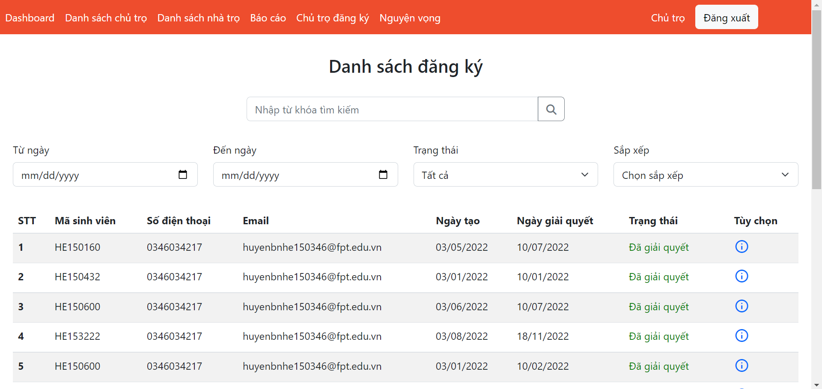

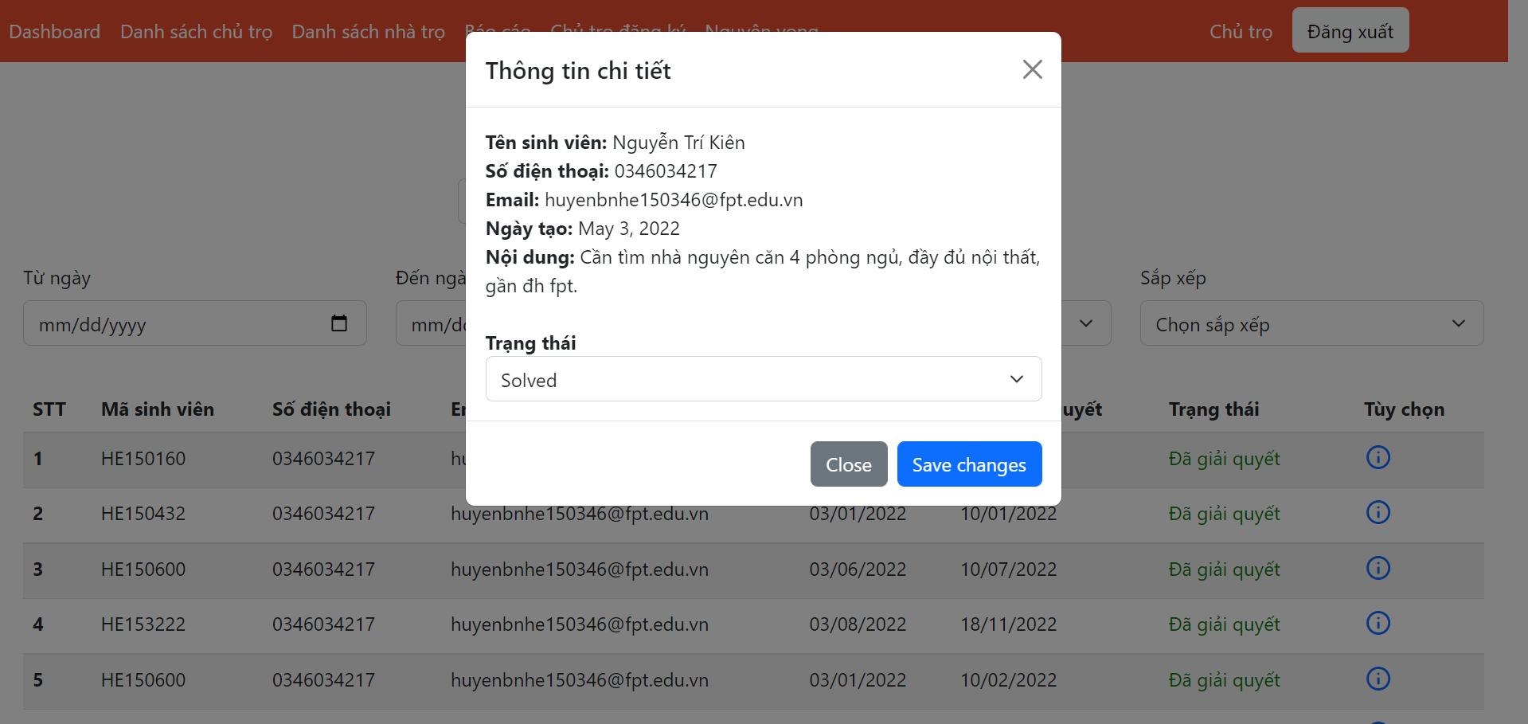

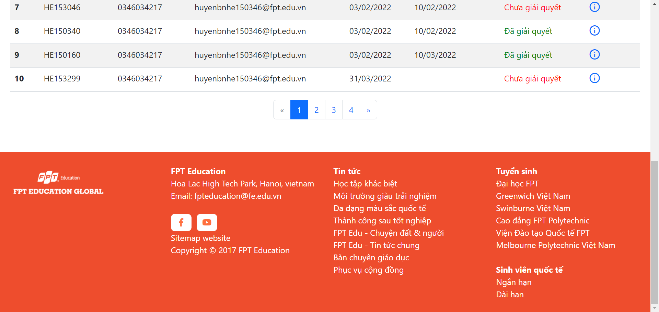

## 4. Non-Functional Requirements

### 4.1 External Interfaces

#### 4.1.1 User Interfaces

UI-1: The FU House Finder System screen displays shall conform to the User Interface Design and User Experience Design

UI-2: The website is designed with the feature of using Angular framework to provide a smooth user experience without having to reload the website many times.

#### 4.1.2 Software Interfaces

SI-1: FU House Finder Account Checking system

SI-1.1: Upload existing user data in the system through a programming interface

SI-1.2: The system automatically checks what state the account is in in the Active attribute of User table

SI-1.3: There will be 2 states including Active and Deactive. If the account is Active, you will be able to perform actions to the system (including managing Landlord’s accounts if you are Staff, and managing Houses if you are Landlord). If the account is Deactive, you will not be able to log in to perform any actions.

SI-2: FU House Finder Inventory System

SI-2.1: House Finder System shall transmit the quantities of house and room items to the House Finder Inventory System through a programmatic interface.

SI-2.2: House Finder System shall poll the House Finder Inventory System to determine whether a requested house item is available.

SI-2.3: The House Finder System will display the available houses left in system for the searching students. If the house is not available, the system will not display for the student to see.

#### 4.1.3 Hardware Interfaces

No hardware interfaces have been identified.

#### 4.1.4 Communication Interfaces

CI-1: FU House Finder shall send an email or send a message to a phone number (based on user account settings) to the Landlord to report any problems reported by students, the Landlord then will present at University campus to resolve.

### 4.2 Quality Attributes

#### 4.2.1 Availability

AVL-1: The FU House Finder website shall be available at least 98% of the time between 5:00 A.M. and midnight local time and at least 90% of the time between midnight and 5:00 A.M. local time, excluding scheduled maintenance windows.

#### 4.2.2 Usability

USB-1: The website shall be designed with user-friendly interfaces so that users could complete the main actions once they see the interface.

USB-2: Landlords shall import the list of their houses within 5 steps.

#### 4.2.3 Localization

LCL-1: The date format must be as follows: date/month/year.

#### 4.2.4 Performance

PE-1: The website must provide 7 seconds or less respond time in a Chrome browser in peak usage condition.

PE-2: The web pages shall fully load in an average of 5 seconds in normal condition.

#### 4.2.5 Security

SE-1: Only admin shall be able to create a new staff’s account and only staff shall be able to approve/reject landlords’ signup request.

SE-2: Landlords must provide their identity card image to be able to sign up a landlord account.

## 5. Requirement Appendix

### 5.1 Business Rules

|  |  |
| --- | --- |
| ID | Rule Definition |
| BR-01 | Only Staff can approve Landlord’s Sign up request and Deactive Landlord’s account. |
| BR-02 | Only Admin can create, modify, or deactive Staff’s account. |
| BR-03 | Landlord can only upload House information after sign up request being approved by Staff. |
| BR-04 | All Passwords require 256-bit encryption. |
| BR-05 | Student’s Search functionality requires at least searching by distance from campus, price and utility. |
| BR-06 | Landlord’s House information upload must adhere to the rules of the template |

### 5.2 Common Requirements

### 5.3 Application Messages List

|  |  |  |  |  |
| --- | --- | --- | --- | --- |
| **#** | **Message code** | **Message Type** | **Context** | **Content** |
| 1 | MSG01 | In the body | There is not any search result | *Rất tiếc, chúng tôi không tìm thấy nhà trọ bạn mong muốn* |
| 2 | MSG02 | Toast message | User not logged into the system | *Vui lòng đăng nhập để sử dụng tính năng này!* |
| 3 | MSG03 | Toast message | Only student can use this feature | *Chỉ học sinh có thể sử dụng tính năng này!* |
| 4 | MSG04 | Toast message | Send order successfully | *Gửi đơn thành công* |
| 5 | MSG05 | Toast message | Send report successfully | *Gửi báo cáo thành công* |
| 6 | MSG06 | Toast message | Comment successfully | *Bình luận thành công* |
| 7 | MSG07 | Toast message | Server error | *Lỗi Server* |
| 8 | MSG08 | Toast message | Ask if you want more rooms? | *Bạn có muốn thêm phòng cho nhà trọ?* |
| 9 | MSG09 | Toast message | Upload room information successfully | *Bạn đã upload thành công thông tin nhà trọ!* |
| 10 | MSG10 | Toast message | Confirm deletion of house | *Bạn chắc chắn muốn xóa nhà trọ này?* |
| 11 | MSG11 | Toast message | Update successfully | *Cập nhật thành công* |
| 12 | MSG12 | Toast message | Error | *Lỗi! Thử lại sau vài giây!* |
| 13 | MSG13 | Toast message | Update room successfully | *Cập nhật phòng thành công!* |
| 14 | MSG14 | Toast message | Add room successfully | *Thêm mới phòng thành công!* |
| 15 | MSG15 | Toast message | Delete room successfully | *Xóa phòng thành công!* |
| 16 | MSG16 | Toast message | Invalid login | *Email hoặc Password không hợp lệ* |
| 17 | MSG17 | Toast message | Confirm deletion of account | *Bạn có muốn xóa tài khoản này?* |

### 5.4 Other Requirements…